Université Côte d’Azur

Academy of Excellence « Networks, Information and Digital Society »

PhD international mobility program
« DocWalker 2024 »
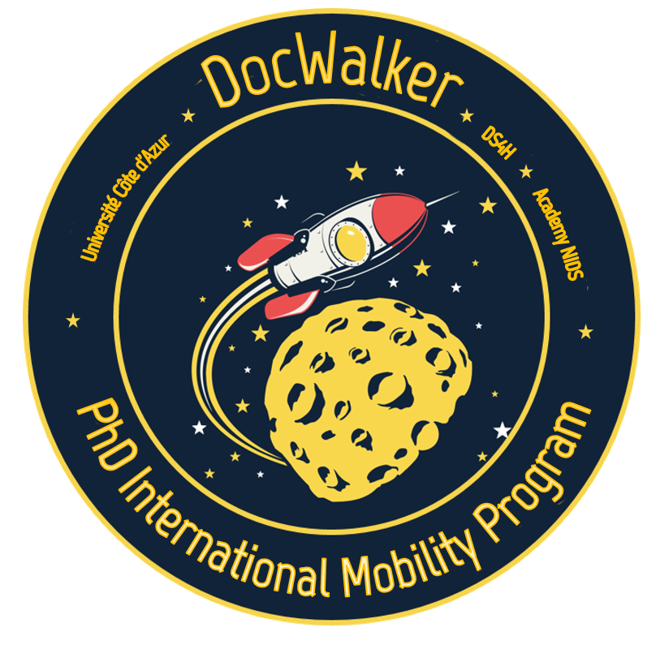
  - September 2023

Project Information Sheet

PhD description
Name of PhD student
Name(s) of supervisor(s)
(specify if joint PhD with foreign university)
UniCA Laboratory or Research entity hosting the
PhD student
PhD student employer
Starting date of PhD
Date of thesis defense
PhD topic
Involved doctoral school
PhD mobility
Foreign Laboratory and University (outside UniCA)
Name and contact within the foreign laboratory
Expected starting date of the PhD mobility
Duration of the mobility (1 to 3 months)
Research topic of the PhD mobility
Required funding | ☐ Travel ☐ Accomodation ☐ Catering
Co-funding | ☐ Yes ☐ No

Summary of the work progress since the start of the thesis
One page maximum
Summarize the motivations of the thesis subject, the positioning in relation to the state of the art and the work done since the beginning of the thesis.

Expected contribution of the PhD mobility
20 lines maximum
Specify how the doctoral stay will contribute to the progress of the PhD thesis. Indicate the scientific impact after the doctoral mobility. What professional prospects for the doctoral student can open after the mobility? What collaborative impact in the short and medium term for the UniCA laboratory or Research entity?

Elements of scientific excellence of the foreign laboratory
10 lines maximum

History of collaboration with the foreign laboratory
10 lines maximum
Specify if this mobility is part of an existing collaboration (possibly list recent common publications). Is there a collaboration agreement with UniCA or the laboratory?

Position relative to the Initiative of Excellence (Idex) and other projects
Is this mobility linked to a project funded by the Initiative of Excellence or any other project funded elsewhere?

Detail of the requested funding
Estimated budget | Description | Cost
Travel |  | €
Accommodation |  | €
Catering |  | €
Other |  | €
Total estimated |  | €
Co-funding |  | -€
Total requested |  | €

Signature of PhD student (mandatory) Signature of PhD supervisor(mandatory)

Director's Visa (desirable prior to submission date)

